**Keep It Simple, Stupid"** or **"Keep It Simple and Straightforward"**

**How it relates to software development:**

In software development, the keep it simple, stupid principle was adopted as an extension of this engineering philosophy. The idea is that **simplicity leads to better designs, fewer bugs, and easier maintenance**. Complex systems, whether mechanical or software-based, tend to be error-prone, harder to understand, and more challenging to fix when things go wrong.

### Problem:

Write a function that checks if a number is even.

Overcomplicated Version

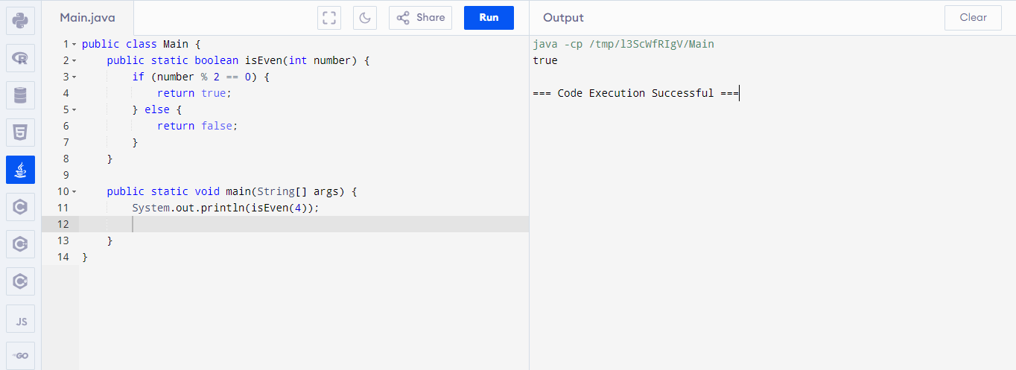

This version includes unnecessary checks and extra logic.

keep it simple, stupid version

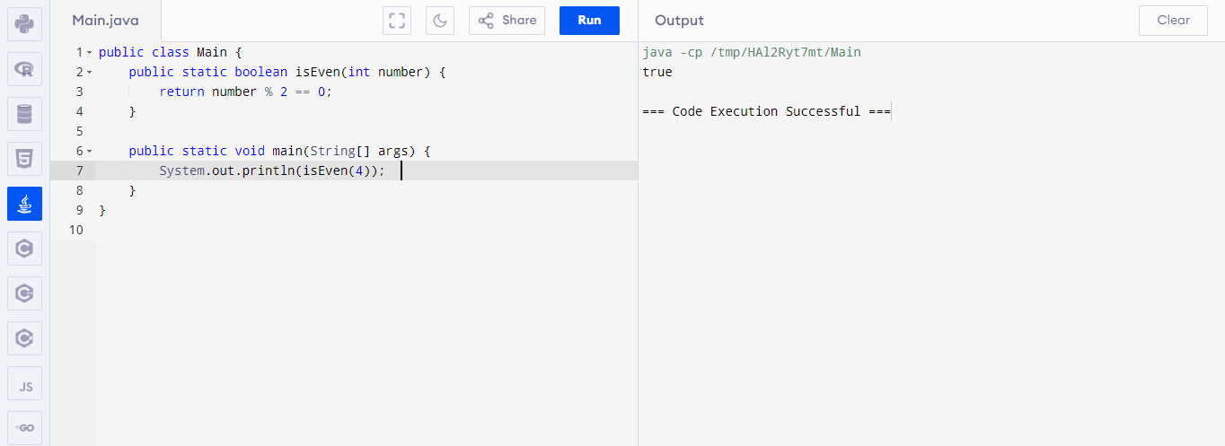

### Why is the second version better?

• **Simple and Direct**: The condition number % 2 == 0 directly returns true or false, making it shorter and easier to understand.

• **No Unnecessary Code**: The if-else block is avoided, keeping the function clean and concise.

This example is short, clear, and effective—just as the keep it simple, stupidprinciple encourages.